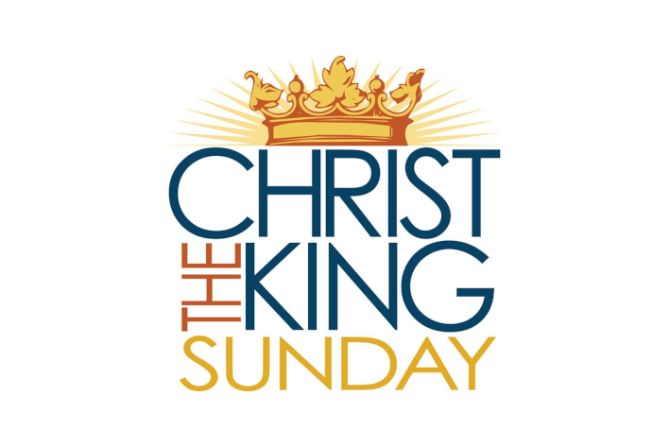

Interested in Baptism

See Pastor Marty

*************************

Bible Study
November 24
December 1, 8 at 1 p.m.

*************************

United Methodist Student Day
Special Offering, November 28

**************************

Men’s Breakfast
Saturday, December 4, 8:30 a.m.

************************

Blue Christmas Service

Sunday, December 5, 4 p.m.
Webberville UMC

*************************

Ladies’ Luncheon
Thursday, December 9, 11:30 a.m.
Sunnyside Café

*************************

Crossroads’ Mission Statement
A Faithful Community Offering Christ to All

*************************

Like us on Facebook….
and invite your friends!

*************************

Crossroads’ Office Hours
Wednesdays: 12-3 p.m.

*************************

Attendance Last Sunday 34
Average Attendance 25

J
J

Christ the King

CROSSROADS UNITED
METHODIST CHURCH
November 21, 2021

We are so glad you’ve joined us this morning!
As you enter this time of worship, we invite you to open your heart to God’s Holy Spirit. We encourage you to take this time to focus on God and his great love for you.

Those Serving in Worship

Pastor: Pastor Marty Johnston

Praise Team: Les Dunckel, Barbara Obst,
Roxi Bass, Bud Hanshew,,
Dawn Smith, Haley Turner,
Rikki Dawn Turner

Pianist: Kim Huston

Liturgist: Roxi Bass

Head Usher: Dean Kitchenmaster

Sound Booth: Kyleigh Kitchenmaster

*************************

r

Crossroads United Methodist Church

5491 Zimmer Road, Williamston, MI 48895
(517) 655-1466
www.umccrossroads.com

Office Hours
Wednesday 12-3 pm
office.umccrossroads@gmail.com

Pastor
Rev. Marty Johnston – (269) 986-7180
pastormartyj@yahoo.com

Music

Doxology

WELCOME

RAISING OUR PRAISE

*CALL TO WORSHIP

Psalm 132:1-5, 11-18 (#849-850 UMH)
(Congregation Reads Bolded Words)

*RAISING OUR VOICES IN SONG

Music

*PASTOR’S OPENING PRAYER

OLD TESTAMENT READING

2 Samuel 23:1-7

Music

YOUTH MESSAGE
(Youth stay seated where they are.)

NEW TESTAMENT READING

John 18:33-37

The Word of God for the People of God

Thanks Be to God

MESSAGE

Christ the King

Pastor Marty Johnston

TIME OF REFLECTION

Speak Lord, for I Am Listening

LIFTING OUR PRAYERS

Response: “Lord, hear our prayer.”

The Lord’s Prayer (#895 UMH)

ANNOUNCEMENTS

*SENDING FORTH

Music

*BENEDICTION

Beloved of God, hear these words of God…

Please stand as you are able or care to do so.

**Taken from the Abington Worship annual 2021
***Adapted from umcdiscipleship.org

* * *

Taking Jesus into the World

Please bring these items for City Rescue Mission: Apple and Grape Juice (large)
Kleenex, Cough Drops

Clean gently used clothing is also appreciated. You can place these items in the yellow barrel in the fellowship hall.

* * *

Scripture Readings for Next Week

Jeremiah 33:14-16, Psalm 25:1-10
1 Thessalonians 3:9-13, Luke 21:25-36

* * *

Interested in Baptism?

See Pastor Marty

* * *

Advent Begins Next Sunday

First Sunday, November 28
Hope

Second Sunday, December 5
Peace

Third Sunday, December 12
Joy

Fourth Sunday, December 19
Love

_________________________________________________

Come to the river of life.
Listen for the words of love.

Come to the waters of grace.
Receive the gift of acceptance.

Come to the river of love,

